1.Create a student table with fields like student roll no,student name,date of birth and address, in access using Design view and enter 5 records of data.
OUTPUT

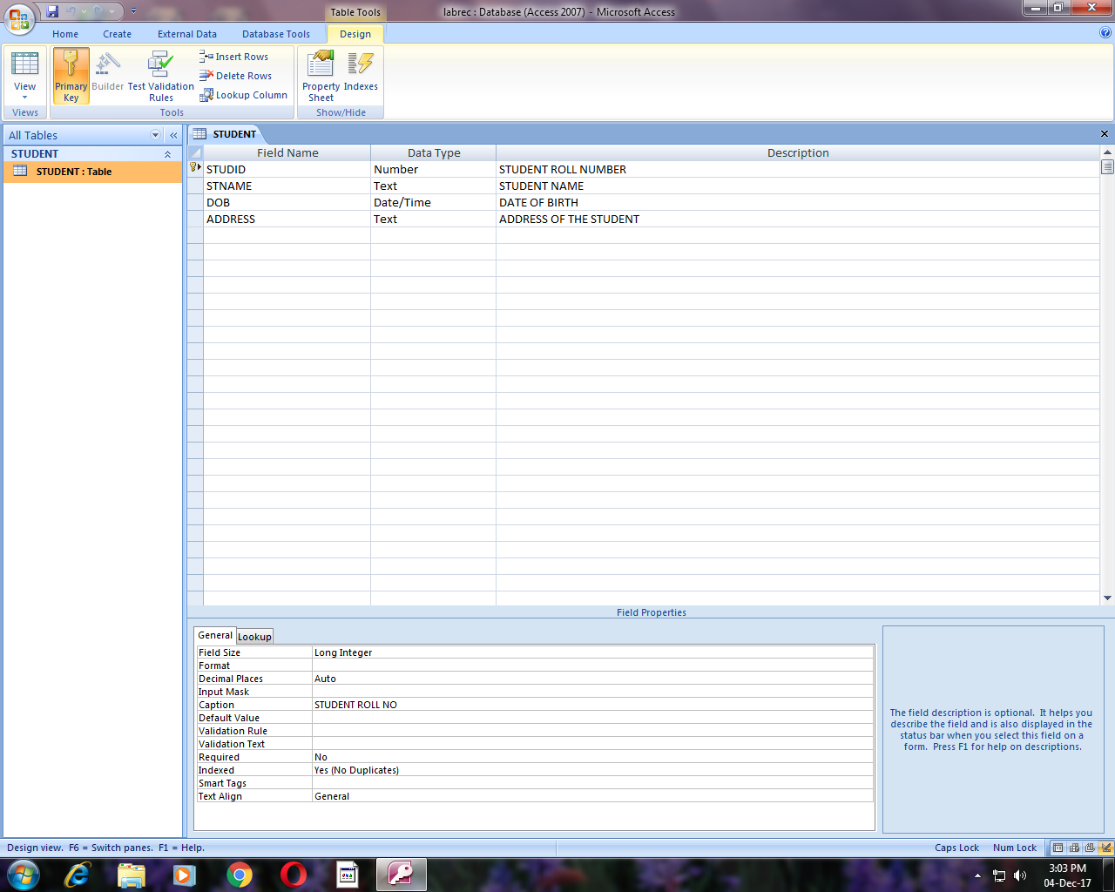

After entering data :

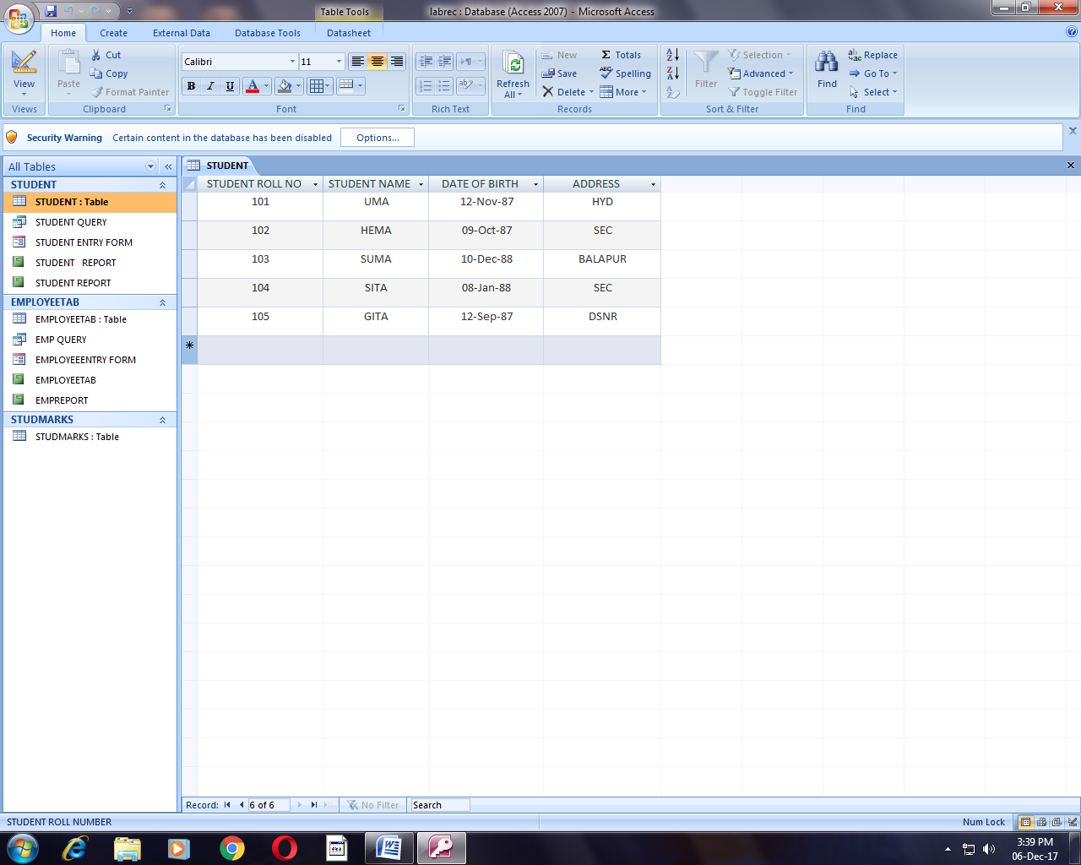

2. Create a student table with fields like student roll no,student name,date of birth and address, in access using table method and enter records of data.
OUTPUT

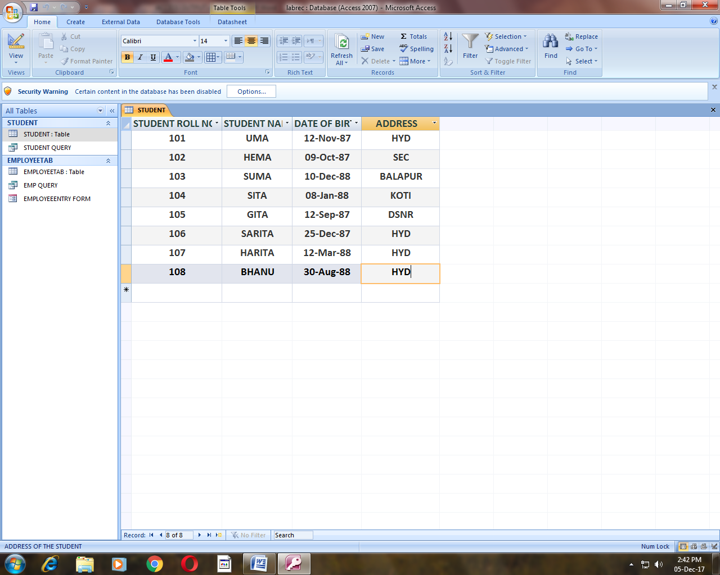

3. Create a form to enter records into an employee table with fields employee id, employee name, designation, department and salary.
OUTPUT

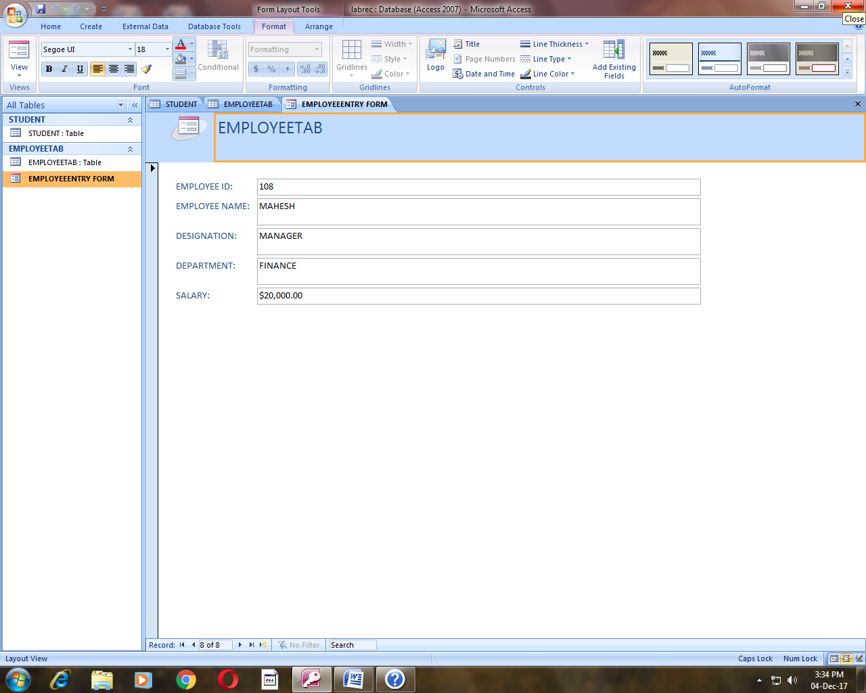

4. Create a form to enter records into student table with fields student id,student name, date of birth and address.
OUTPUT
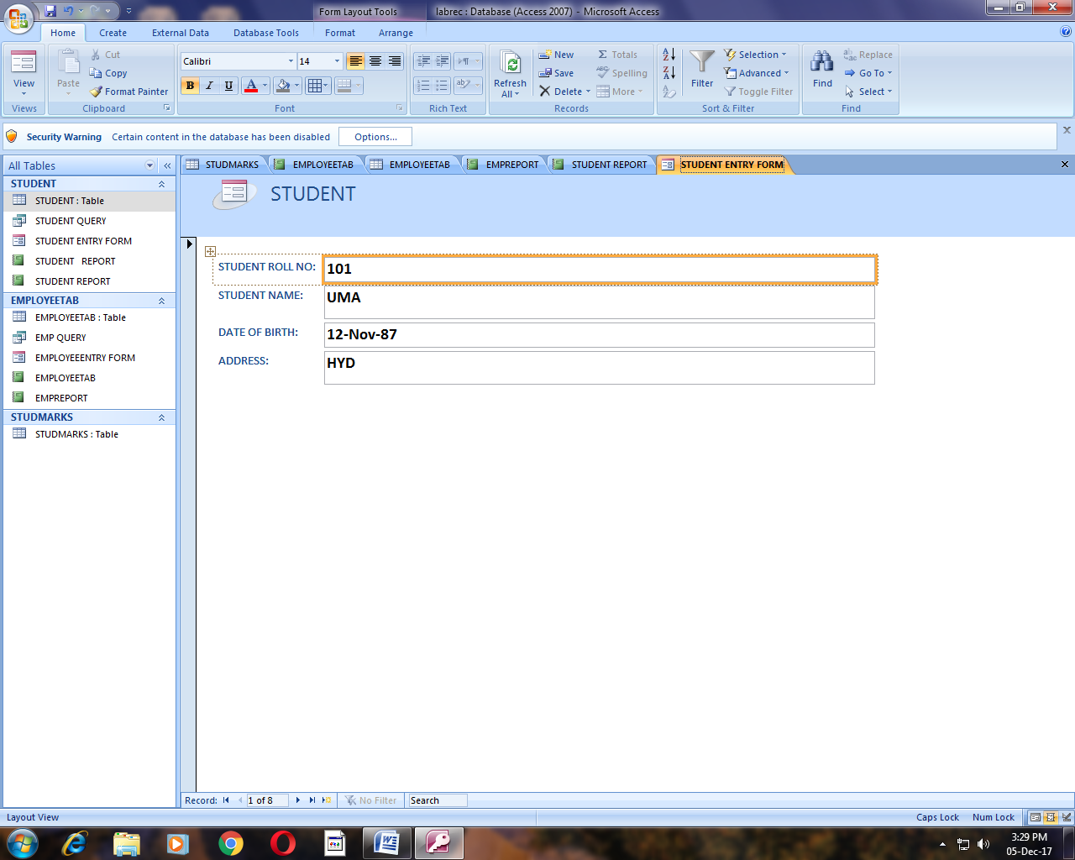

5. Create a query to retrieve records from an employee table with fields employee id, employee name, designation, department and salary. (condition :retrieve all clerks records)
OUTPUT
Designing query :

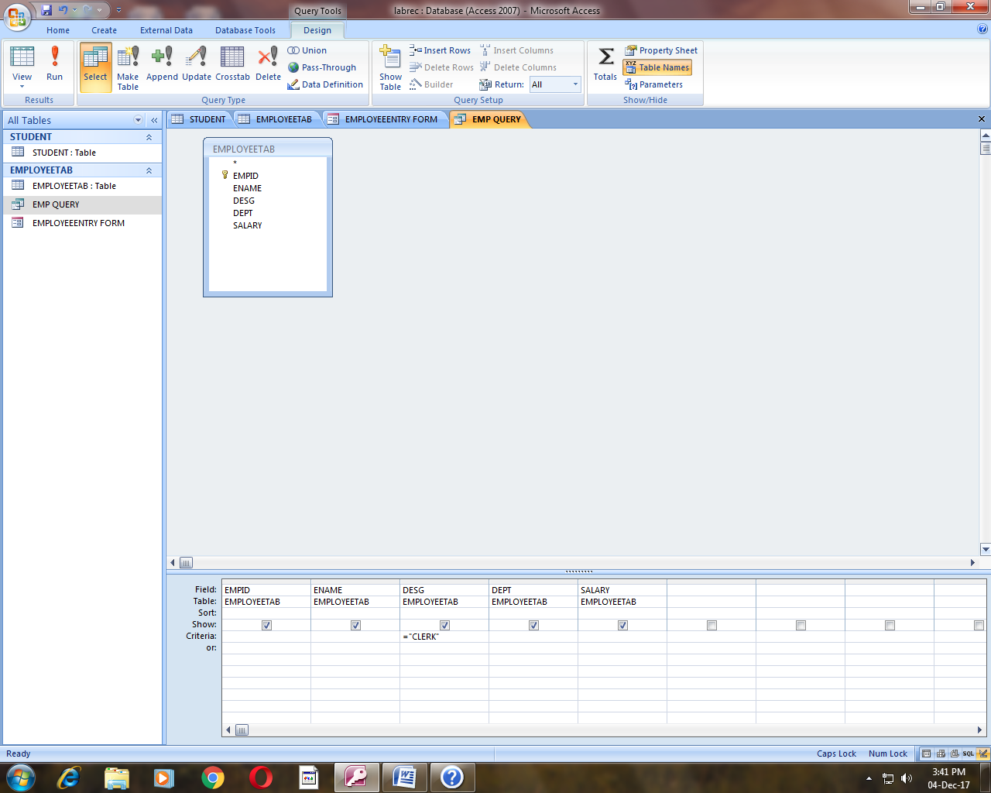

Query output :

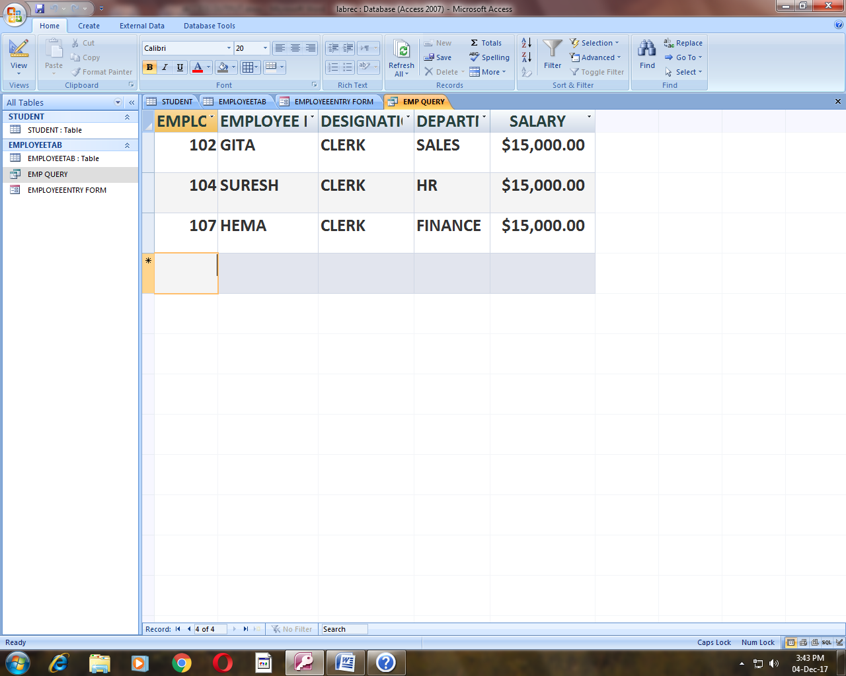

6. Create a query to retrieve records from a student table with fields student roll no,student name,date of birth and address (condition : students residing in HYD).

OUTPUT
Designing query :

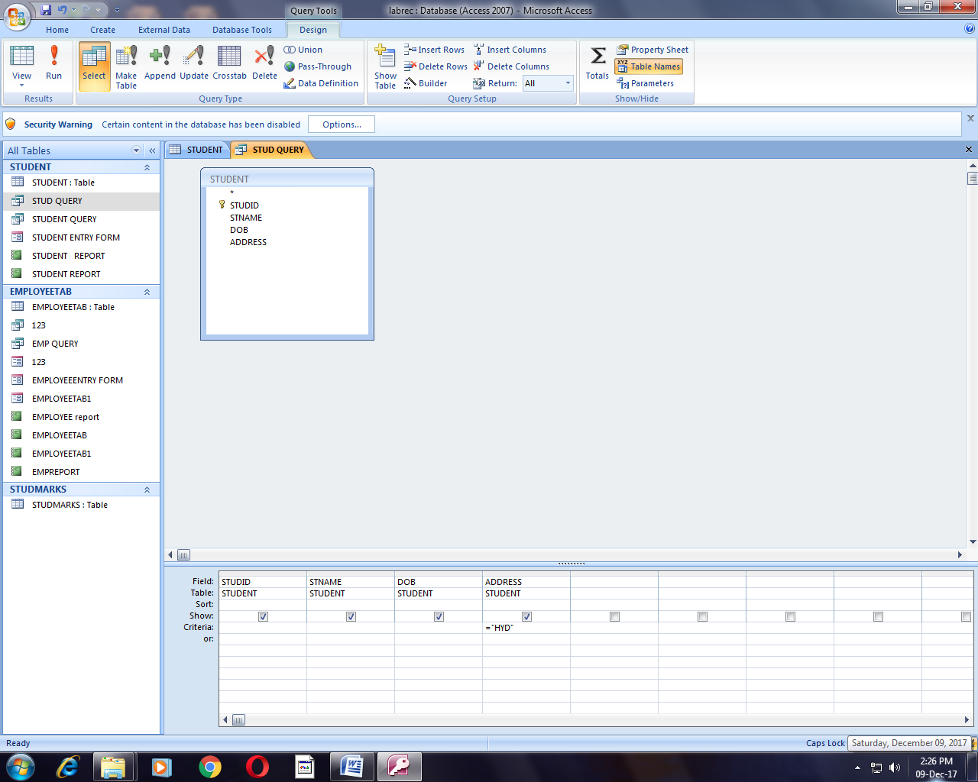

Query output :

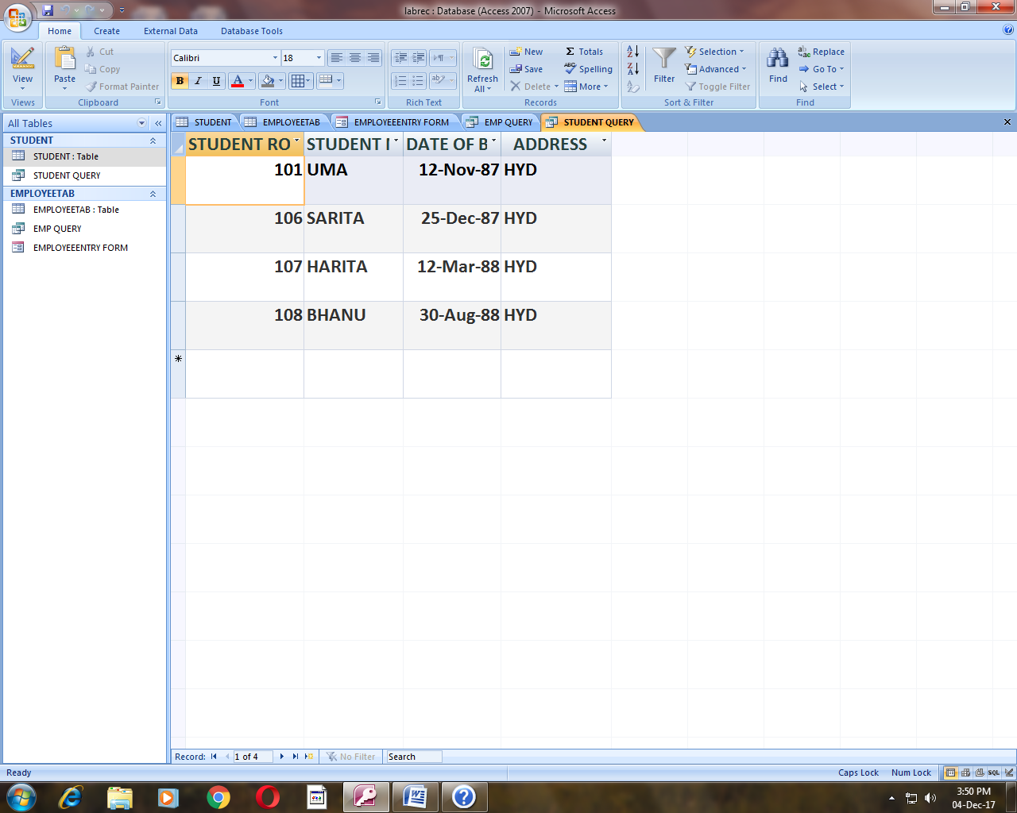

7. Create an employee report grouped according to department.
OUTPUT
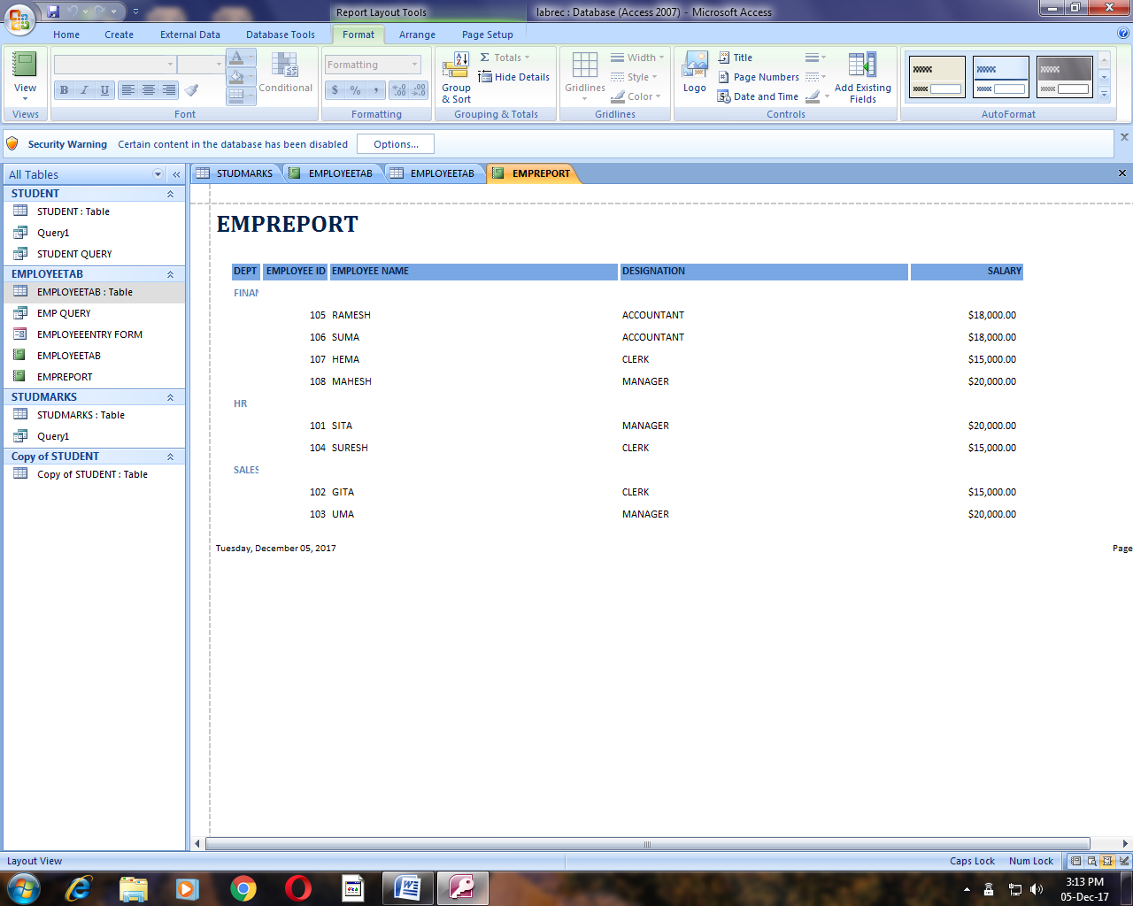

8. Create a student report grouped according to address.
OUTPUT
